Benjamin Linam

[Bml42@students.uwf.edu](mailto:Bml42@students.uwf.edu)

EEL 4744L: Microprocessor Applications Laboratory

Lab 8: Output Compare

4/10/2018

**Objective**

The object of this lab is to study and understand the output compare functions of the 68HC11.

**Introduction/Background/Theory**

The 68HC11 has five output compare function pins that are able to be controlled to produce a waveform. Realistically, that wave can be used to control a device such as one involved in the operation of a vehicle. The output compare pins (OC2) can be set with certain commands such as a toggle once the TCNT counter reaches a set TOC2 value. Being able to toggle between 0 V and 5 V easily allows control over a waveform with a certain frequency and duty cycle. This lab requires creation of a program that is controlled by a 3-switch dip switch to output 8 different waves shown in Table 1. To show that the desired waveforms are created, an oscilloscope is to be used to measure frequencies and duty cycles, which are shown in figures 3 through 10.

**Table 1**: Dip Switch values represented by C2:C0 with the corresponding frequencies and duty cycles.

|  |  |  |
| --- | --- | --- |
| C2:C0 | Frequency | Duty Cycle |
| 000 | 1kHz | 10% |
| 001 | 1kHz | 30% |
| 010 | 2kHz | 40% |
| 011 | 2kHz | 50% |
| 100 | 2kHz | 60% |
| 101 | 4kHz | 70% |
| 110 | 4kHz | 80% |
| 111 | 4kHz | 90% |

**Procedure**

1. Much of the code for this lab requires adjusting binary values being read by accumulators and action registers, so the hexadecimal values saved to the initial variables should be looked at as binary instead of hexadecimal. Figure 1 shows that the first operation is setting Port C, which reads input values from a 3-switch dipswitch, to input by setting pins PC0-PC2 to 0.

2. The next operation is preparing OC2 to toggle after a set interval defined by the HITIME and LOTIME arrays shown in Figure 2. Before toggling the OC2 pin, the requesting input value from the dip switch is read, ANDed with 0’s to force any undesired input to 0, and the offset required to produce each specific signal is calculated and stored at TOC2 for the next toggle. Since each high or low time is a 2-byte value, the offset is found by multiplying the dip switch value with 2 (performed by a logical shift left). After a toggle, the TFLG1 is cleared in preparation for the next toggle.

3. Once the wave generation has begun, a loop will cause the wave to alternate between high and low to produce the specified frequency and duty cycle.

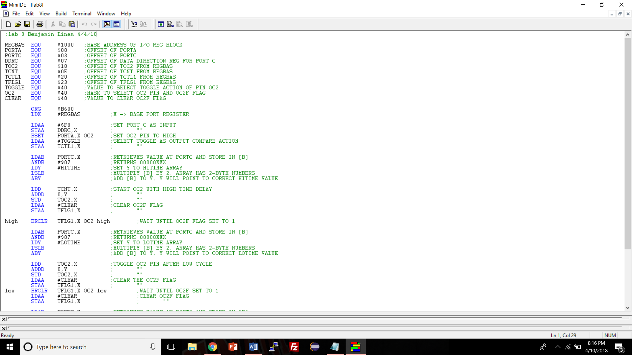

**Figure 1**: ASM code showcasing code controlling initialization of variables and setting of initial signal generation

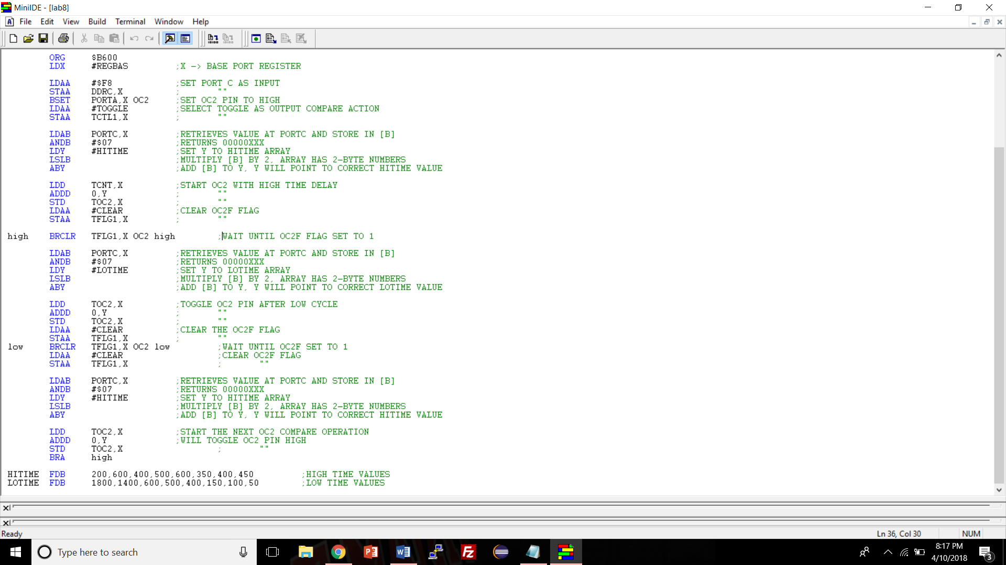

**Figure 2**: ASM code showcasing code controlling dip switch testing and wave generation loop

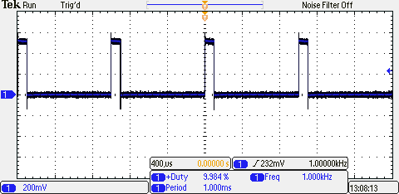

**Figure 3**: Oscilloscope representation of 1 kHz wave with 10% Duty Cycle

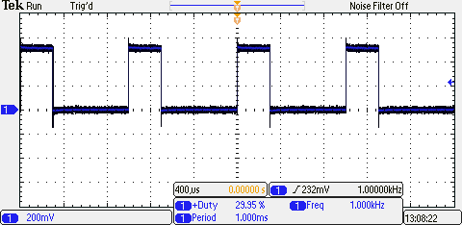

**Figure 4**: Oscilloscope representation of 1 kHz wave with 30% Duty Cycle

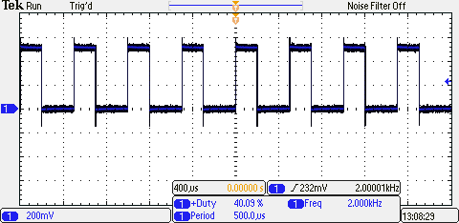

**Figure 5**: Oscilloscope representation of 2 kHz wave with 40% Duty Cycle

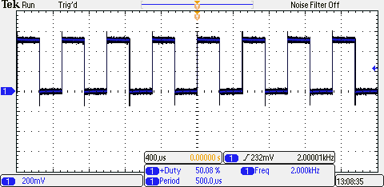

**Figure 6**: Oscilloscope representation of 2 kHz wave with 50% Duty Cycle

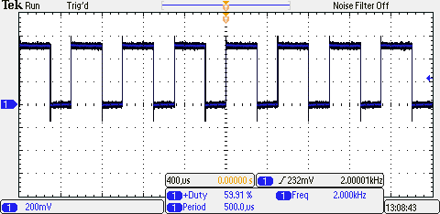

**Figure 7**: Oscilloscope representation of 2 kHz wave with 60% Duty Cycle

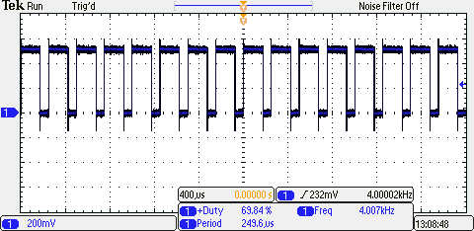

**Figure 8**: Oscilloscope representation of 4 kHz wave with 70% Duty Cycle

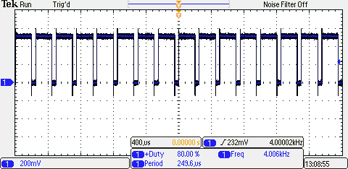

**Figure 9**: Oscilloscope representation of 4 kHz wave with 80% Duty Cycle

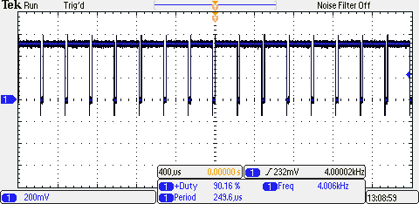

**Figure 10**: Oscilloscope representation of 4 kHz wave with 90% Duty Cycle

**Conclusions**

Not very many problems were encountered during the creation and debugging of this program. Initially I created the dip switch checking portion of the code with several branch statements, but I streamlined the code by testing the dip switch values and determining the desired wave just before each toggle was activated. During testing of the code in the lab, the only problem I had was that I forgot to include a pound sign (#) before initializing Port C as well as ANDing the input values.